INSTRUCTIONS FOR DEVELOPERS

# Pre-install requirements

* Eclipse (recommended: Eclipse Luna)
  + Plugins: m2eclipse,
* Java SDK 1.8
* Maven
* GitHut

# Compilation of projects

1. Checkout or download the projects from GitHub repository <https://github.com/Web-of-Building-Data/drumbeat-ifc2ld> to folder **drumbeat-ifc2ld** (you can use another name if you want).
2. Open Eclipse, create a new workspace and add all the existing projects from folder **drumbeat-ifc2ld** to the workspace (click menu File🡪Import🡪General🡪Existing Projects into Workspace, then select all projects from the folder and click button *Finnish*).

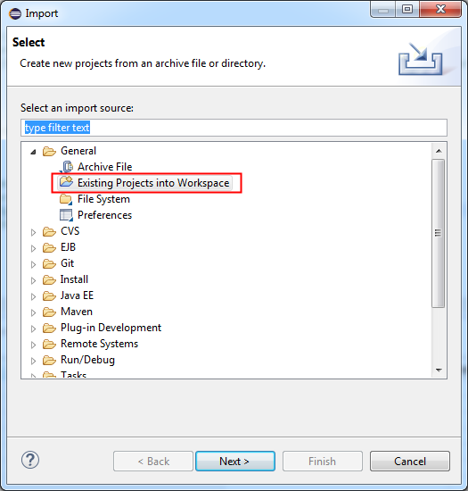

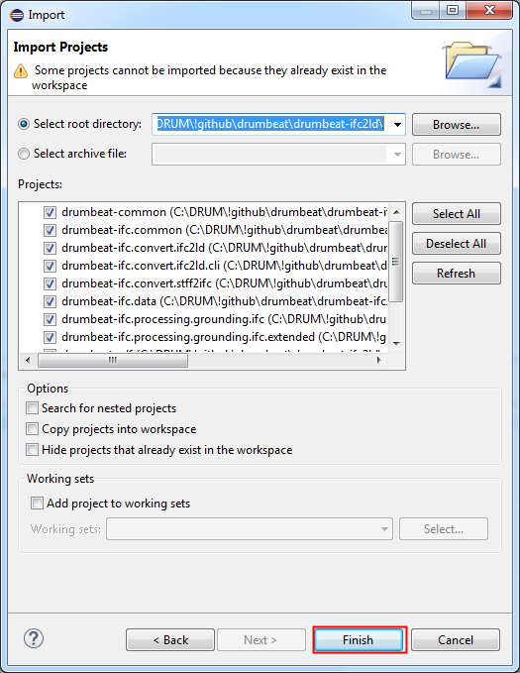

1. For each project do the following steps:
   1. Open the Project Properties, choose *Java Build Path*, then open tab *Libraries*

